Assignment-1
Name:R.sai kundan

Ht.no:2303A51413
Batch.No:21

1Q)Task1:AI-GeneratedLogicWithoutModularization (Factorial without
Functions) Promptused:
writeapythoncodetocalculatethefactorialofanumberwithout using any functions and input should be taken from user.
Code:
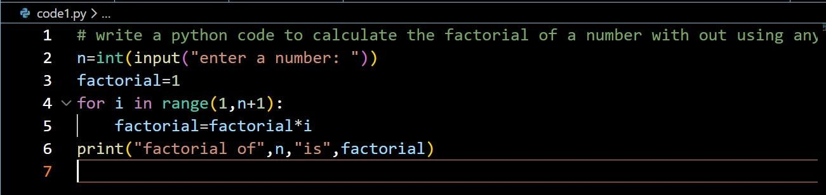
Output:
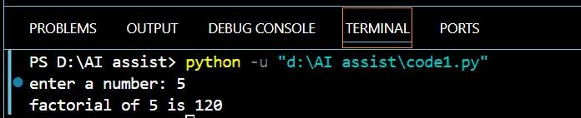
Justification:
Bydoingthistask,thefactorialofanumberiscalculatedwithout using any functions.
Theprogramtakesinputfromtheuserandusesasingleforloopto compute the factorial.

Allstepsarewrittendirectlyinthemainprogramusingiterative logic.

2Q)Task2:AICodeOptimization&Cleanup(Improving Efficiency)
Promptused:
optimizetheabovecodebyaddingcomments,readabilityandwith improved logic.
Code:
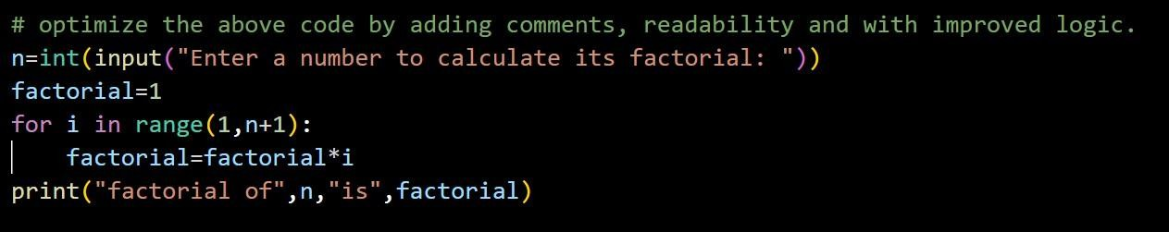
Output:
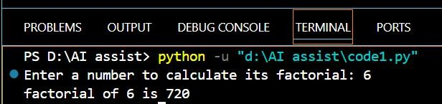
Justification:
Bydoingthistask,thefactorialprogramisoptimizedforbetter readability and understanding.
Meaningfulcommentsandclearvariableusageareaddedwhile keeping the logic simple and efficient.
Theprogramstillusesasingleloopanduserinput,withallsteps written in the main program.

3Q)Task3:ModularDesignUsingAIAssistance(Factorialwith Functions)

Promptused:
- write a python code to calculate the factorial ofa number using meaningfuluserdefinedfunctionsandtakingtheinputfromthe user.
- ifusergivesnegativenumbersthenthiscodeshouldhandlethat case as well.
Code:
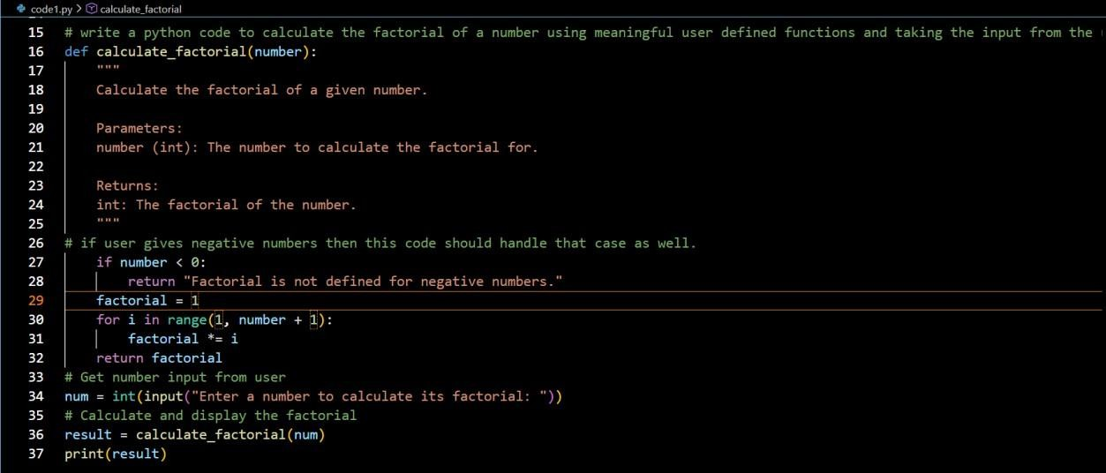
Output:
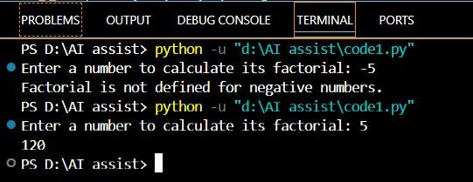
Justification:
Bydoingthistask,thefactoriallogicisimplementedusinga meaningful user-defined function.
Theprogramtakesinputfromtheuserandhandlesnegativenumbers with proper validation.

Modulardesignimprovescodereadability,reusability,anderror handling.

4Q)Task4:ComparativeAnalysis–ProceduralvsModularAI Code (With vs Without Functions)

Criteria WithoutFunctions (ProceduralCode)
Logiciswrittenlinearlyin oneplace,whichiseasyto
With Functions (ModularCode)
Logicisclearly separated into

LogicClarity

Reusability
followforsmallprograms but becomes cluttered as code grows.

Code cannot be reused easily; the same logic must berewrittenifneededagain.
meaningful functions, makingthefloweasier to understand.
Functionscanbereused multiple times across the program or in other programs.

Debugging
DebuggingisharderbecauseEasiertodebugsince
alllogicismixedin themainerrorscanbeisolated

Ease

Suitabilityfor Large Projects

AI
Dependency Risk

Conclusion:
program.

Notsuitableforlarge projects due to poor structure and maintainability.
Higherrisk,asAI-generated logic may be copied blindly without understanding due to lack of structure.
withinspecific
functions.
Highly suitable for largeprojectsbecause ofcleanstructureand modular design.
Lowerrisk,asmodular design encourages understandingoflogic, inputs, and outputs.

Proceduralcodeisusefulforsmall,simpletasksandbeginners,while

modularcodeusingfunctionsisbettersuitedforscalable, maintainable, and professional software development.

5Q)Task5:AI-GeneratedIterativevsRecursiveThinking
- Aniterativeversionofthelogic Prompt used:
write a python code to calculate the factorial of a number using iterativeapproachwithmeaningfuluserdefinedfunctionsandtaking the input from the user.
Code:
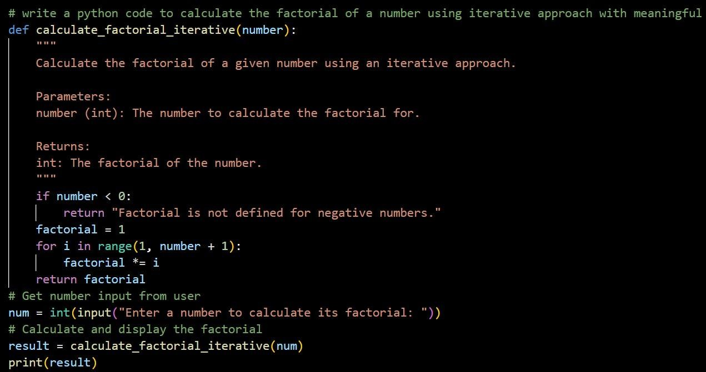
Output:
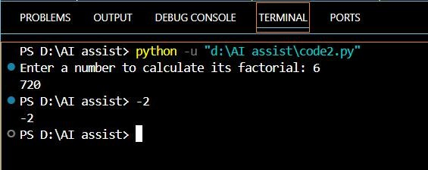

- Arecursiveversionofthesamelogic Prompt used:
write a python code to calculate the factorial of a number using recursiveapproachwithmeaningfuluserdefinedfunctionsandtaking the input from the user.

Code:
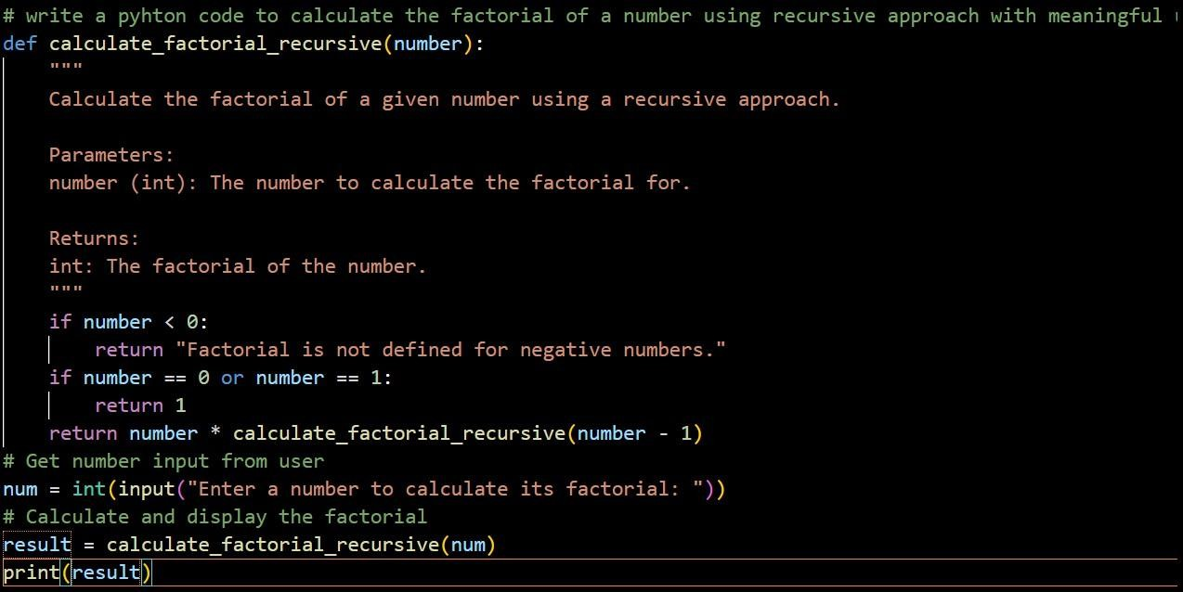
Output:
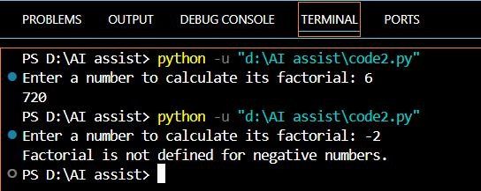
Justification:
Bydoingthistask,factoriallogicisimplementedusingbothiterative and recursive approaches.
Theiterativeversionusesaloopforstep-by-stepmultiplication,while

therecursiveversionusesfunctioncallsandbaseconditions.
Thiscomparisonhelpsunderstanddifferencesinreadability,stack usage, performance, and when recursion should be avoided.

